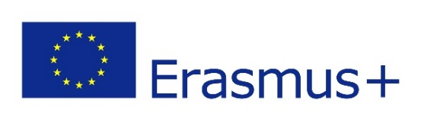
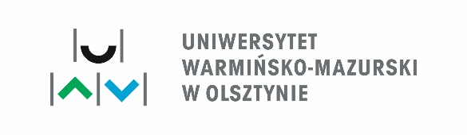
APPLICATION FORM

STUDENT MOBILITY FOR STUDIES

ERAMSUS+ PROGRAMME KA107 – 2019
HIGHER EDUCATION STUDENT AND STAFF MOBILITY BETWEEN PROGRAMME AND PARTNER COUNTRIES
APPLICATION FORM SHOUDL BE FILLED ELECTROCINALLY, SIGNED AND STAMPED
- NAME AND SURNAME
- STUDYING AT
(UNIVERSITY, FACULTY)
- CITIZENSHIP
- ADRESS
- PHONE NUMBER
- NUMBER OF FINISHED HIGHER EDUCATION STUDY YEARS
- DEGREE FOR WHICH YOU ARE CURRENTLY STUDYING
(BACHELOR/ENGINEER; MASTER, DOCTORAL)
- DO YOU WANT TO APPLY FOR A PLACE IN A DORMITORY?
(yes/no)
- E-MAIL
- PASSPORT NUMBER
- DATE OF THE MOBILITY  (FROM FIRST TILL LAST DAY OF THE MOBILITY – WITHOUT TRAVEL) | FROM first day of the mobility - calendar  TILL last day of the mobility- calendar

I familiarized myself with the mobility regulations operating at the University of Warmia and Mazury in Olsztyn in the frame of Erasmus+ Programme for partner countries.
Date and signature of an applicant  ................................................................. | Date, signature and a stamp of an  Erasmus+ Coordinator  (FORM HOME UNIVERSITY  .................................................................

Consent for the processing of common personal data by University of Warmia and Mazury

I hereby give my consent for the processing of my personal data by the University of Warmia and Mazury in Olsztyn, Michała Oczapowskiego 2, 10-719 Olsztyn, Poland, for the purpose of mobility in the frame of Erasmus+ Programme .
We hereby inform you that you have the right to withdraw your consent at any time by delivering a completed consent withdrawal request form to the UWM Data Protection Supervisor. The withdrawal consent form can be downloaded from:www.uwm.edu.pl/daneosobowe.
The withdrawal of consent shall not affect the lawfulness of processing based on your consent before its withdrawal.

…………………………
^{(signature)}

